Project Design Phase
Solution Architecture
Date | 10 October 2026
Team ID | —————————————
Project Name | Car Rental Request Automation in ServiceNow Using Service Catalog and Workflows
Maximum Marks | 4 Marks

Solution Architecture
Solution architecture is a multi-step discipline that links business problems to technology solutions. Its aims are to:
- Select the best technical approach to the existing business problems.
- Explain the structure, characteristics and behavior of the software to project stakeholders.
- Define features, development phases and solution requirements.
- Provide the specifications by which the solution is defined, managed and delivered.
Solution Architecture Diagram
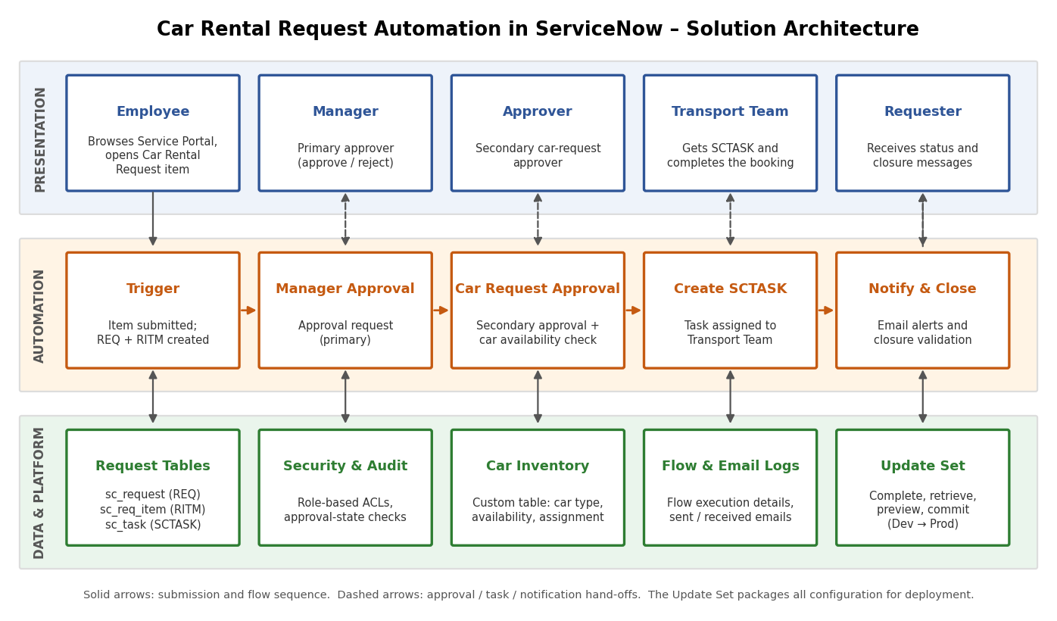
Figure 1: Architecture and data flow of Car Rental Request Automation in ServiceNow
Reference: ServiceNow Product Documentation – Service Catalog and Flow Designer (https://docs.servicenow.com)
Architecture Overview
The solution is organized in three layers. The presentation layer is the Service Portal and Service Catalog, where employees raise requests and where managers, approvers and the transport team respond to them. The automation layer is a Flow Designer flow backed by Business Rules; it routes approvals, checks car availability, creates tasks and sends notifications. The data and platform layer stores the request tables, car inventory, security rules and the Update Set used for deployment.
Key Components
- Catalog item – Car Rental Request: variables for requested date, pick-up location, drop location, duration, car type and reason, with client scripts for mandatory-field and auto-fill validation.
- Flow Designer: starts on catalog submission and runs the primary manager approval, the secondary car request approval, the availability check, SCTASK creation, notifications and closure validation.
- Business Rules: assign tasks to the Transport team automatically, update the request status after approvals and send notifications when work is complete.
- Data tables: sc_request (REQ), sc_req_item (RITM), sc_task (SCTASK), sysapproval_approver for decision history, and a Car Inventory table (or external data source) for availability and assignment.
- Security: role-based access for requesters, managers, approvers, the transport team and admins, enforcement of approval states, and audit logging of requests, approvals and notifications.
- Deployment: every configuration change is tracked in an Update Set, marked Complete, retrieved on the target instance, previewed and committed.
Data Flow
1) The employee submits the catalog item and the REQ and RITM records are created. 2) The flow sends the request to the manager for approval. 3) Once approved, the secondary car request approval runs and car availability is checked. 4) An SCTASK is created and assigned to the Transport team. 5) Notifications go out at every stage, and the request is closed after fulfillment is validated.
Technology Stack
ServiceNow instance (with admin access), Service Catalog, Service Portal, Flow Designer / Workflow Engine, Business Rules, Client Scripts, Script Includes, Notifications and Update Sets.

